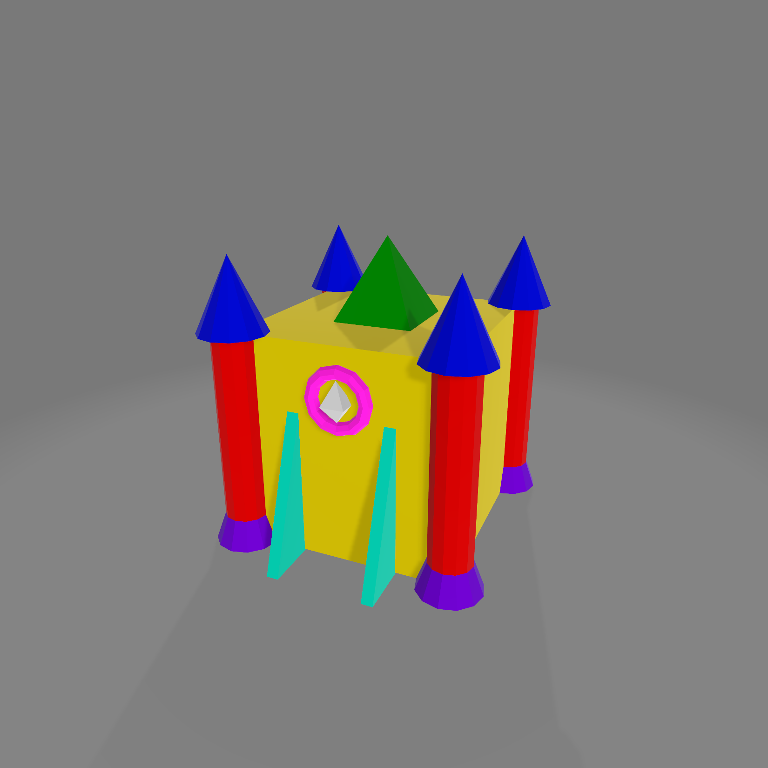

|  |  |  |  |  |  |
| --- | --- | --- | --- | --- | --- |
|  |  | **X** | **Y** | **Z** | **Geometry Gen Function** |
| Castle | Box | 0 | 0 | 0 | CreateBox() |
| Pyramid | 0 | (Box.h / 2) + (this.h / 2) | 0 | CreateSquarePyramid() |
| Front Right Column | Cone | Box.l / 2 | (Box.h / 2) + (this.h / 2) | Box.w / 2 | CreateCone() |
| Cylinder | Box.l / 2 | 0 | Box.w / 2 | CreateCylinder() |
| Half Cone | Box.l / 2 | (-Box.h / 2) + (this.h / 2) | Box.w / 2 | CreateCylinder() where topRadius < bottomRadius |
| Front Left Column | Cone | -Box.l / 2 | (Box.h / 2) + (this.h / 2) | Box.w / 2 | CreateCone() |
| Cylinder | -Box.l / 2 | 0 | Box.w / 2 | CreateCylinder() |
| Half Cone | -Box.l / 2 | (-Box.h / 2) + (this.h / 2) | Box.w / 2 | CreateCylinder() where topRadius < bottomRadius |
| Back Right Column | Cone | Box.l / 2 | (Box.h / 2) + (this.h / 2) | -Box.w / 2 | CreateCone() |
| Cylinder | Box.l / 2 | 0 | -Box.w / 2 | CreateCylinder() |
| Half Cone | Box.l / 2 | (-Box.h / 2) + (this.h / 2) | -Box.w / 2 | CreateCylinder() where topRadius < bottomRadius |
| Back Left Column | Cone | -Box.l / 2 | (Box.h / 2) + (this.h / 2) | -Box.w / 2 | CreateCone() |
| Cylinder | -Box.l / 2 | 0 | -Box.w / 2 | CreateCylinder() |
| Half Cone | -Box.l / 2 | (-Box.h / 2) + (this.h / 2) | -Box.w / 2 | CreateCylinder() where topRadius < bottomRadius |
| Front Gate | Diamond | 0 | Box.h / 4 | Box.w / 2 | CreateDiamond() |
| Torus | 0 | Box.h / 4 | Box.w / 2 | CreateTorus |
| Left Wedge | -Box.l / 2 | (-Box.h / 4) + (this.h / 2) | Box.w / 2 | CreateTriangularPrism() |
| Right Wedge | Box.l / 2 | (-Box.h / 4) + (this.h / 2) | Box.w / 2 | CreateTriangularPrism() |